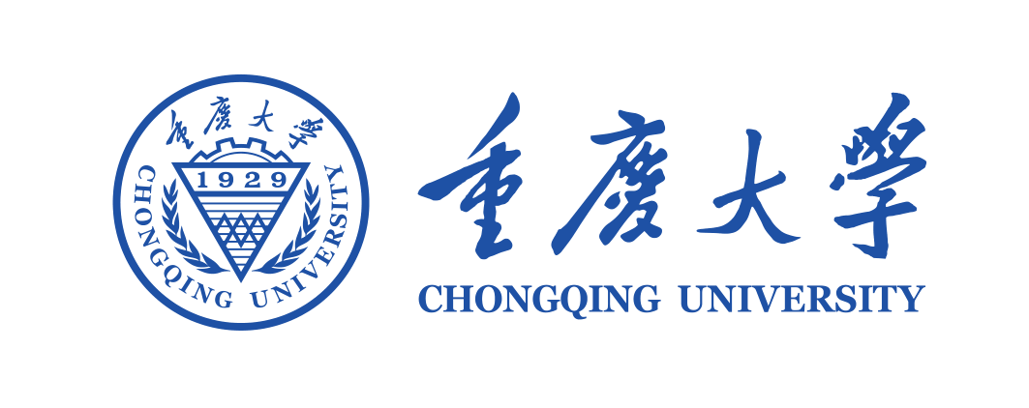
Certificate Letter

Visa Section,
The Sweden (国家) Consulate General in Beijing（签证处所在城市）, China

To whom it may concern,

This is to certify that Mr./Miss Guijian XIAO, undergraduate \graduate \Ph.D.(三选一) candidate from School of Mechanical Engineering (学院名称), Chongqing University is scheduled to attend the 19th International Symposium on Advances in Abrasive Technology - ISSAT 2018（会议的名称） to be held in Stockholm, Sweden（会议城市，国家） from October 2nd to October 5th, 2018（会议起止时间）.（如果有多项任务请统一按如上表述，并用“；”隔开。） We have approved his/her leave and upon return to China, he/she will continue to study in the School of Mechanical Engineering（学院名称） in Chongqing University.

The expenses of this trip including international flight tickets, insurance, accommodations and the local transportation will be covered by Short-term International Academic Communication Fund （研究生“短期国际学术交流项目”）/ School of Mechanical Engineering, Chongqing University （XX学院）/ his supervisor’s research funding at Chongqing University（导师科研经费） / Chongqing University （重庆大学）(经费来源四选一).
He/She was enrolled in Chongqing University in September, 2013, and more information related to him/her is as below:

Name | Date of Birth | Passport Number | Status
Guijian XIAO | 16 MAY 1986 | E12343342 | Ph.D. Candidate

Your support to his/her visa application will be highly appreciated.

Sincerely yours，

Mr. Huang He
Office of International Affairs, Chongqing University
People’s Republic of China
Date: March 8, 2018
Tel: 023-6510 3019
Fax: 023-6510 6656

